Wireshark Assignments
Sai Madhuhas Kotini
700762696

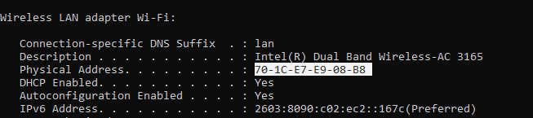
MAC of my device is 70-1C-E7-E9-08-B8

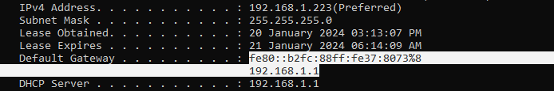
MAC of my Gateway is fe80::b2fc:88ff:fe37:8073%8

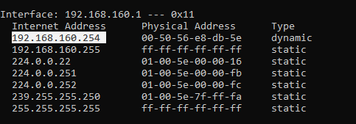
My IP address of my default gateway is 192.168.160.254 and it is dynamic type.

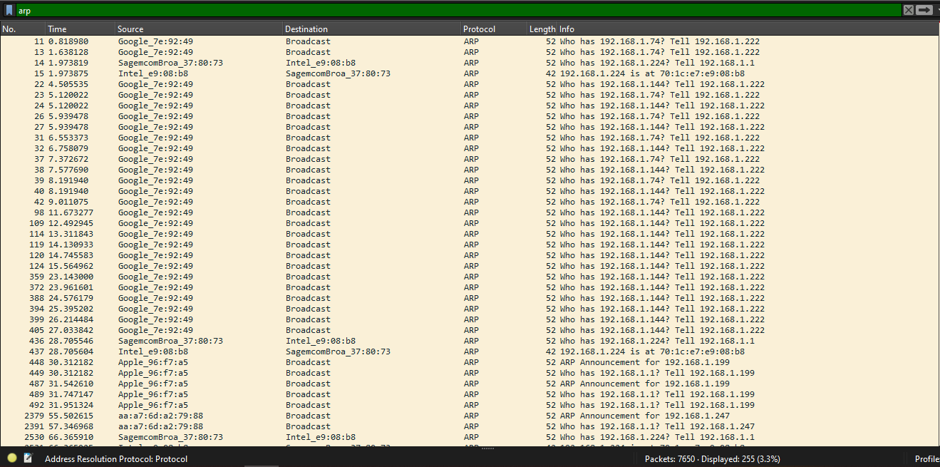
ARP messages (complete request)
In a capture length of seven minutes, I got a total of 255 ARP messages.
The Address Resolution Protocol (ARP) is a crucial protocol used to map an IP address to a physical or MAC address on a local network through a request-response mechanism. When an ARP message is broadcast to all devices on the network, the device that matches the IP address responds with its MAC address.
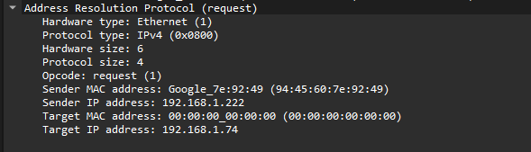
Through ARP protocol we can see the other devices which are connected on the same network
In the above image you can see the connected device MAC address and IP address.
ARP are mostly broadcast messages. ARP lets us listen to other devices which are on same network. Although it masks the data packets ARP is not a secure protocol.
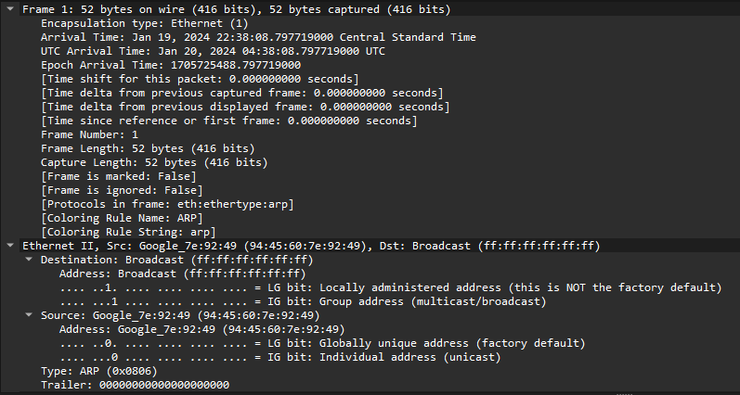

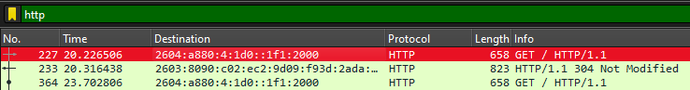
HTTP request
Host: httpforever.com\r\n
Source: 2603:8090:c02:ec2:9d09:f93d:2ada:6685
Destination: 2604:a880:4:1d0::1f1:2000
Protocol: HTTP
Port: 80

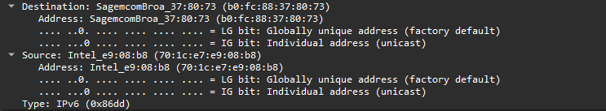
As you can see in the above picture the destination and the source of the http site.
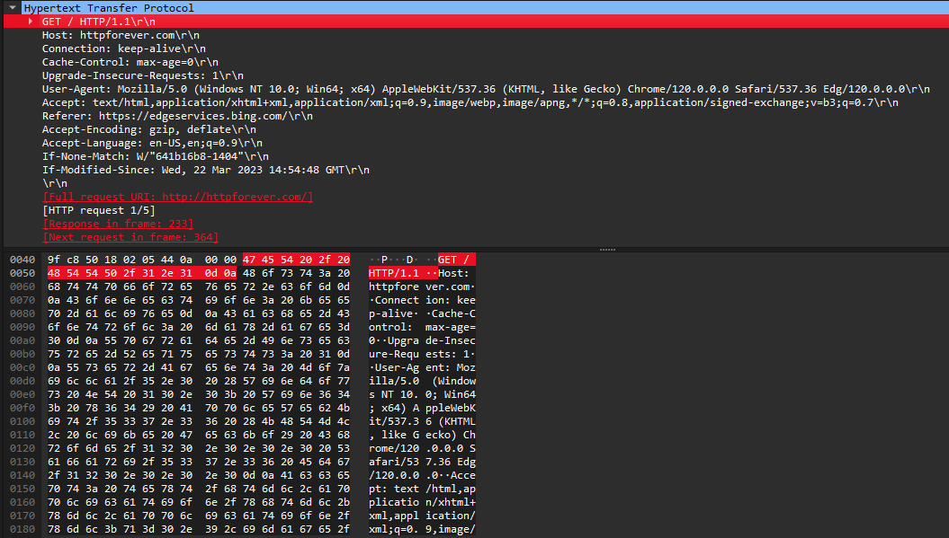
This is an HTTP/1.1 connection, these messages were openly sent across the connection.
The above request is calling an HTTP method which is GET,
GET indicates that a resource should be fetched.
You can see a blank line indicating all meta-information for the request has been sent.
As this message is openly sent across the connection you can see the body containing data associated with the request. The presence of the body and its size is specified by the start-line and HTTP headers.

HTTPs request
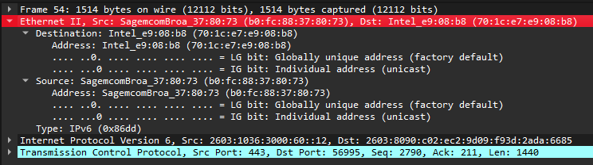
Source: 2603:1036:3000:60::12
Destination: 2603:8090:c02:ec2:9d09:f93d:2ada:6685
Protocol: TCP
HTTPS typically runs over TCP.
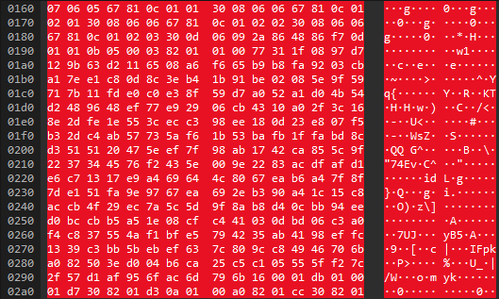
The payload is encrypted.
This communication protocol in HTTPS is encrypted using Transport Layer Security (TLS). This encryption ensures that the data exchanged between the browser and server is secure and cannot be read by anyone who intercepts the exchange of data.
Unlike http, https is more secure. HTTP exchanges data as plain text, which leaves it vulnerable to interception, thereby making it easily readable by anyone involved. Conversely, HTTPS encrypts the communication protocol through Transport Layer Security (TLS), ensuring that the data exchanged between the browser and server remains secure and inaccessible to any unauthorized individual. Additionally, HTTP uses the default port 80, while HTTPS uses the default port 443.

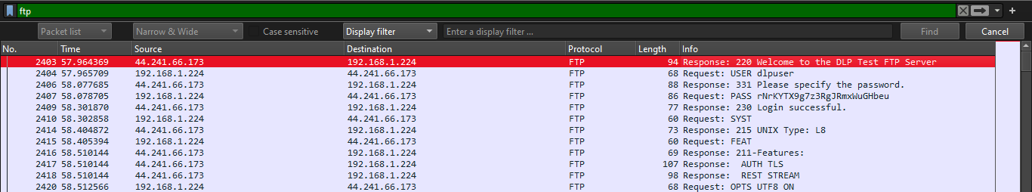
FTP
FTP URL: ftp.dlptest.com or ftp://ftp.dlptest.com/
FTP User: dlpuser
Password: rNrKYTX9g7z3RgJRmxWuGHbeu
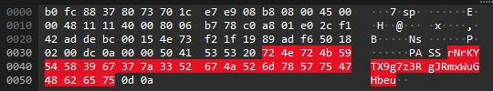
As you can see this connection is not secure, you can see the password.
Once the connection is established, we are trying to capture a download from the server.
Here we are requesting a file actorstoday.txt from FTP.
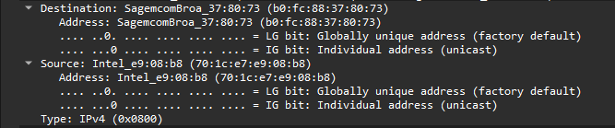
Source: 192.168.1.224
Destination: 44.241.66.173
Protocol: FTP
Length: 76

To get a file from FTP it follows three steps.
- Request: RETR actorstoday.txt
- Response: 150 Opening BINARY mode data connection for actorstoday.txt (0 bytes)
- Response: 226 Transfer complete.
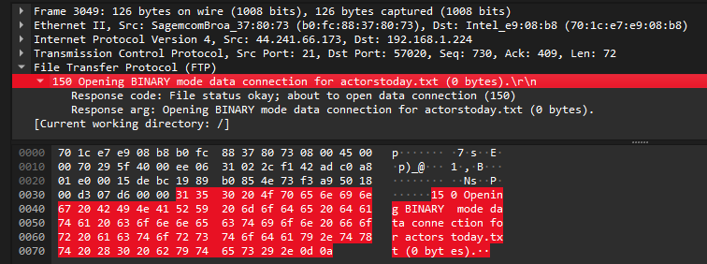
Response: 150 Opening BINARY mode data connection for actorstoday.txt (0 bytes)
Transferring file from server to local.
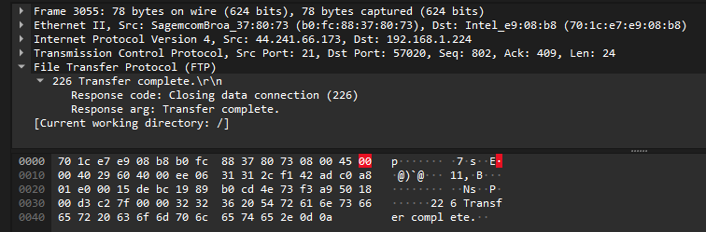
File Transfer complete.
FTP uses plain text passwords, which makes it vulnerable to a variety of security attacks like sniffing, spoofing, and brute force attacks.
As you can see in the above FTP traffic capture you can see your login credentials and other sensitive information by analyzing the data in Wireshark.

To ensure that your FTP file transfer remains secure, it's recommended to follow these best practices:
- Consider using SFTP or FTPS.
- Use strong passwords that are difficult to guess or crack.
- Implement firewalls and intrusion detection systems (IDS).
- Conduct regular server audits to identify and fix any vulnerabilities.

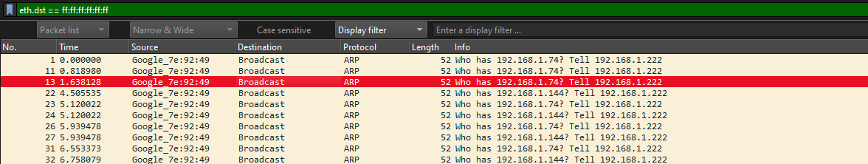
Broadcast Messages
A broadcast message is sent to all devices on a network segment to discover other devices. ARP and DHCP are examples of protocols that use it. In the above capture it is using ARP protocol.
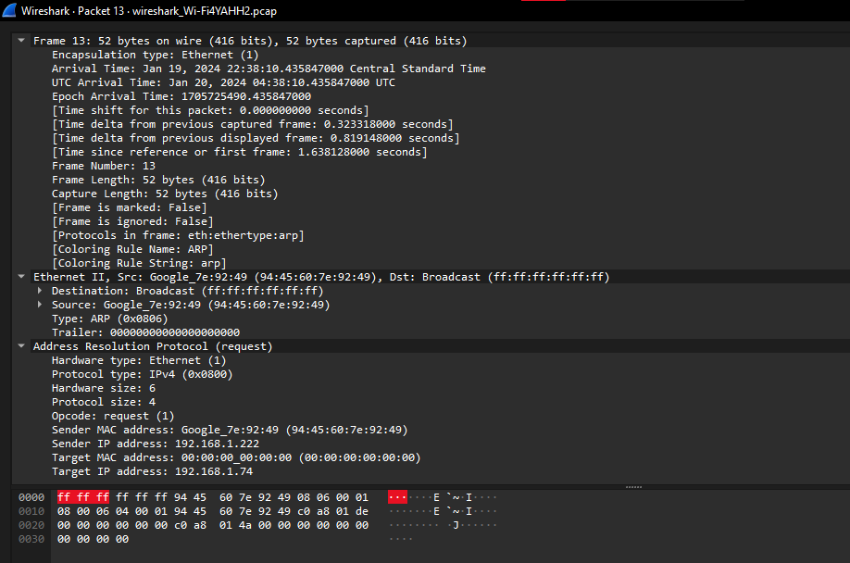
A broadcast messages are identified by the destination MAC address of ff:ff:ff:ff:ff:ff .

Two Different methods of ICMP Packets
ICMP is a network layer protocol used for error control, reporting and management queries. Routers use it to send error messages and operations information. Two popular ways to send ICMP packets to a specific destination are traceroute and ping. Traceroute is used to know the route between two devices connected over the internet. Ping measures the time taken by data to reach the destination and return to the source.

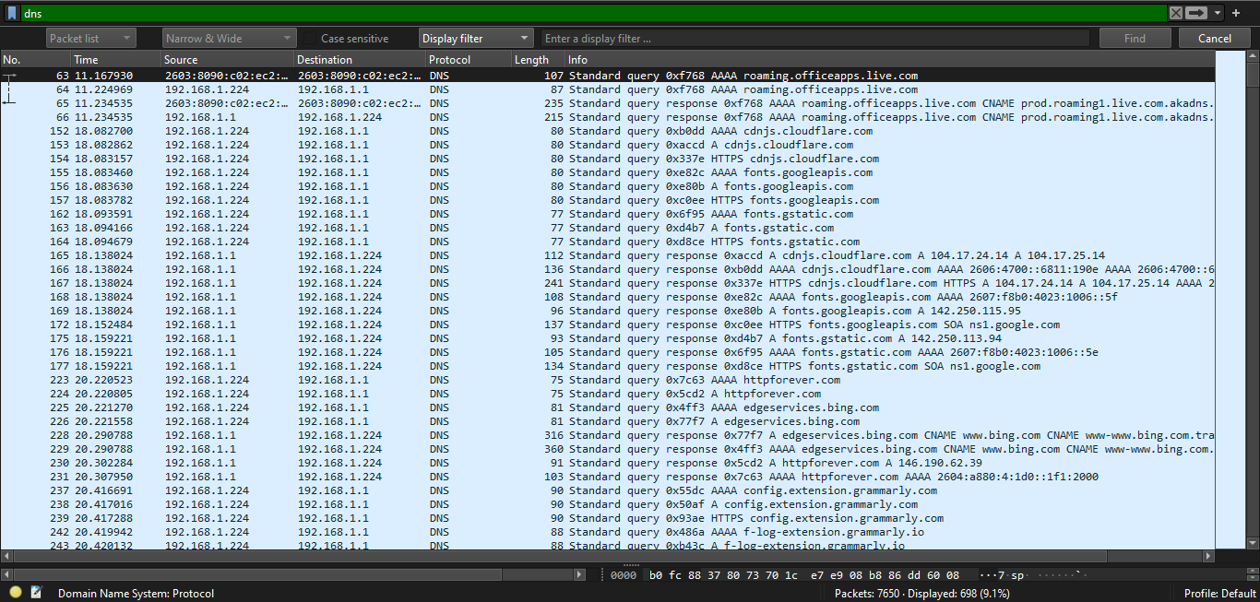
DNS Messages
In a capture length of seven minutes, I got a total of 698 DNS messages.
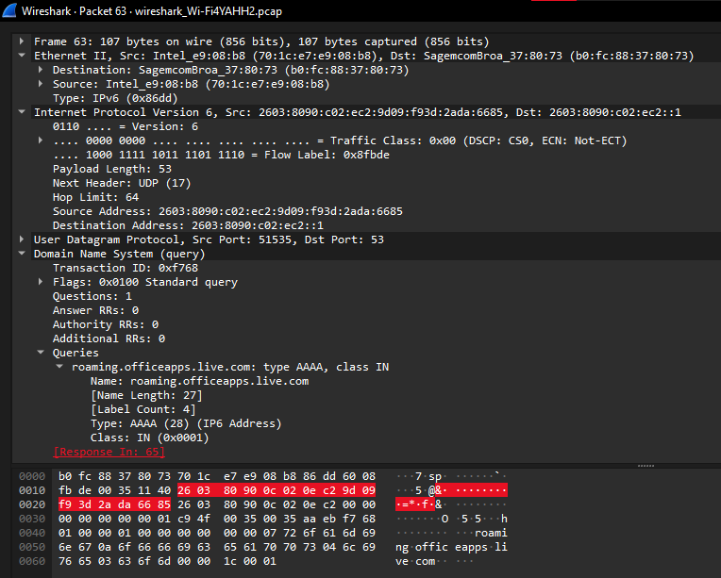 Use DNS over TLS (DoT) or DNS over HTTPS (DoH) to encrypt DNS queries and responses and improve user privacy and security. DNSSEC adds cryptographic signatures to DNS records and helps prevent DNS spoofing attacks.
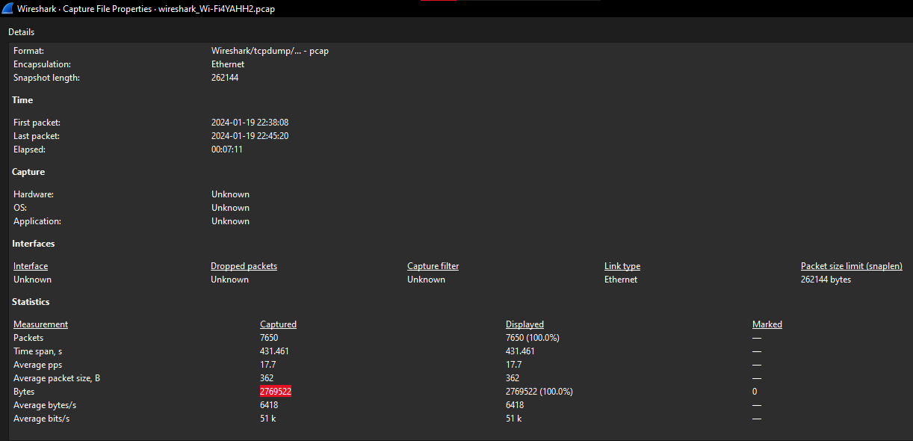
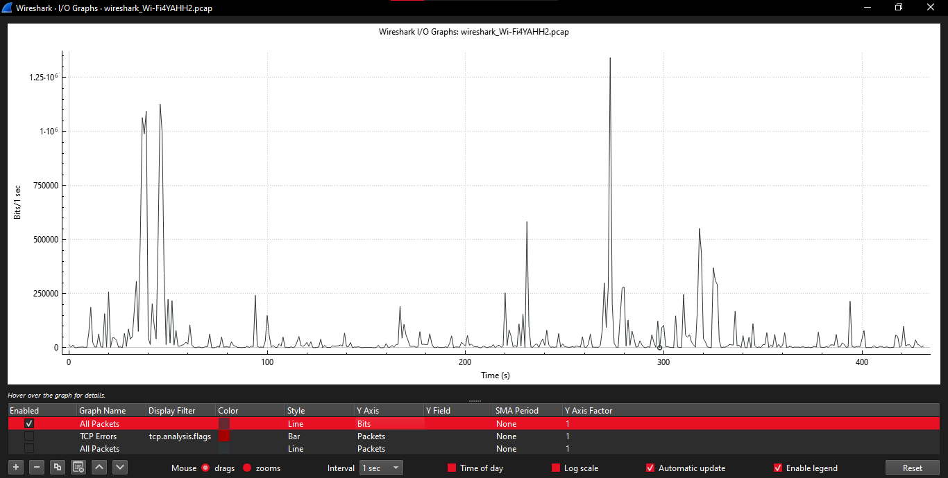
Total amount of bandwidth captured during the session is 51 k.
The total amount of packets during the capture is 7650.

TCP
Source: 2603:1036:3000:60::12
Destination: 2603:8090:c02:ec2:9d09:f93d:2ada:6685
Protocol: TCP
The payload is encrypted.
This communication protocol in TCP is encrypted using Transport Layer Security (TLS). This encryption ensures that the data exchanged between the browser and server is secure and cannot be read by anyone who intercepts the exchange of data.

TCP is a reliable protocol that enables a byte stream service between two hosts. It's a full-duplex protocol that supports a pair of byte streams. TCP allows the sender to send data in the form of a stream of bytes and the receiver to accept data in the same form. Both sender and receiver are connected through a virtual circuit.
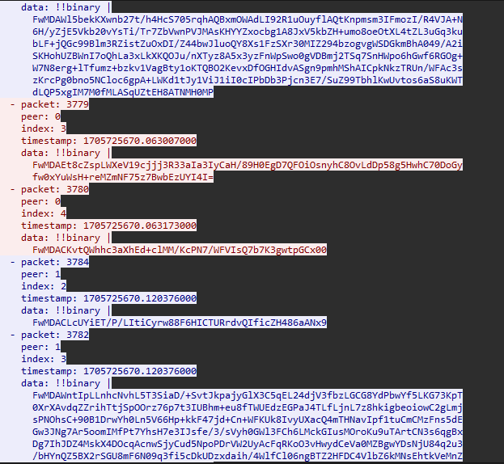
Flow of TCP Stream.
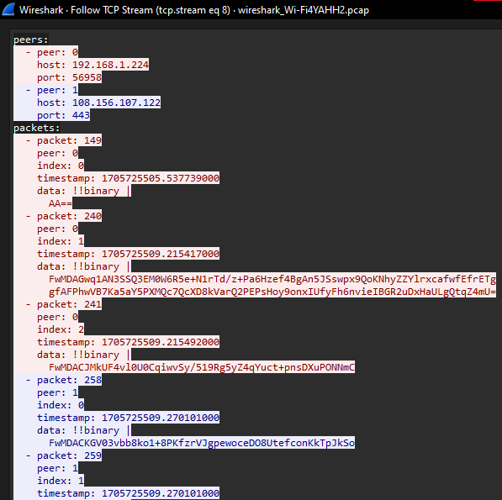

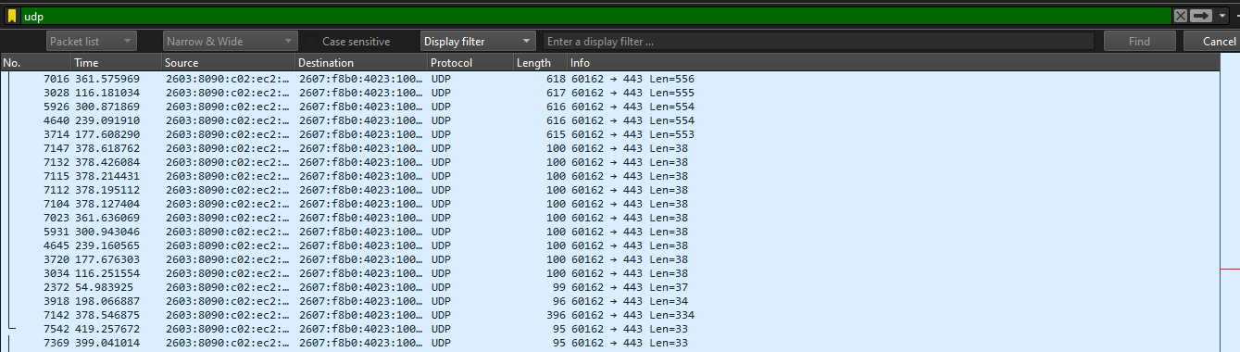
UDP
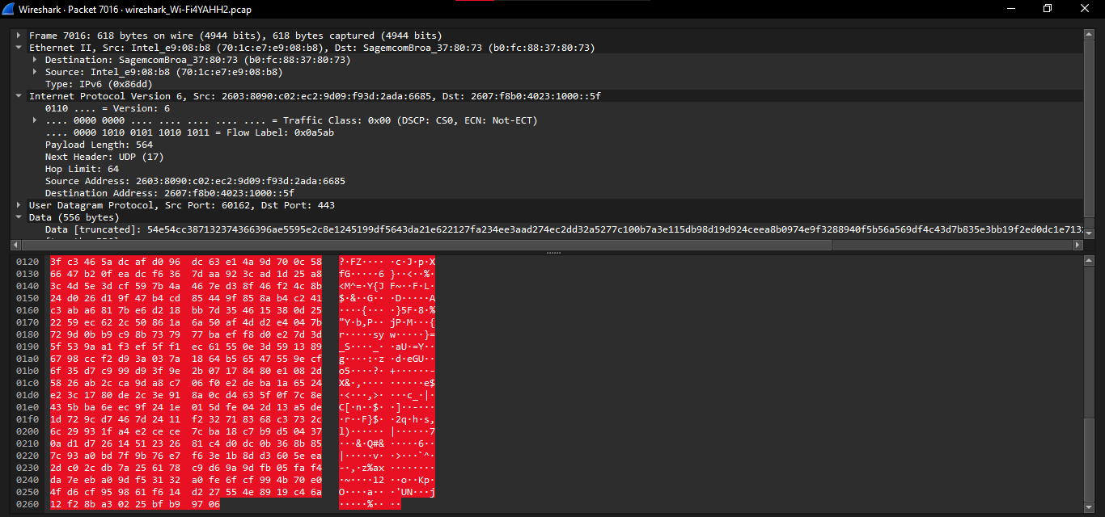
Source: 2603:8090:c02:ec2:9d09:f93d:2ada:6685
Destination: 2607:f8b0:4023:1000::5f
Protocol: UDP
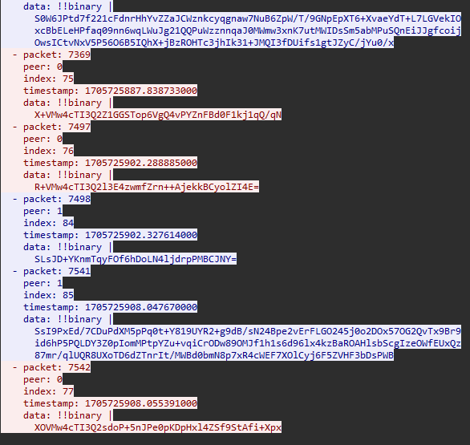
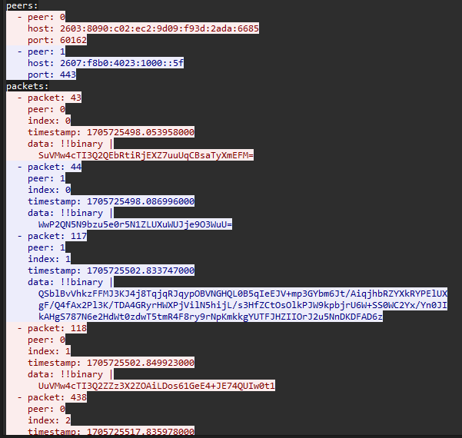
Flow of UDP Stream.

UDP (User Datagram Protocol) is a connectionless, unreliable protocol that sends data in the form of self-contained, independent datagrams. It allows two hosts to communicate by sending datagrams without establishing a connection beforehand. However, UDP does not guarantee the delivery of packets, nor does it provide any mechanism for retransmission of lost packets. This is the responsibility of the application layer.

Feature | TCP | UDP
Connection | Connection-oriented | Connectionless
Reliability | Reliable | Unreliable
Error checking | Yes | No
Flow control | Yes | No
Congestion control | Yes | No
Speed | Slower than UDP | Faster than TCP
Usage | Used for applications that require reliable data transfer, such as email, file transfer, and web browsing | Used for applications that require low-latency and loss-tolerating communication, such as online gaming, video streaming, and VoIP

Packet number summary between all the IP addresses in the capture is 7,010.

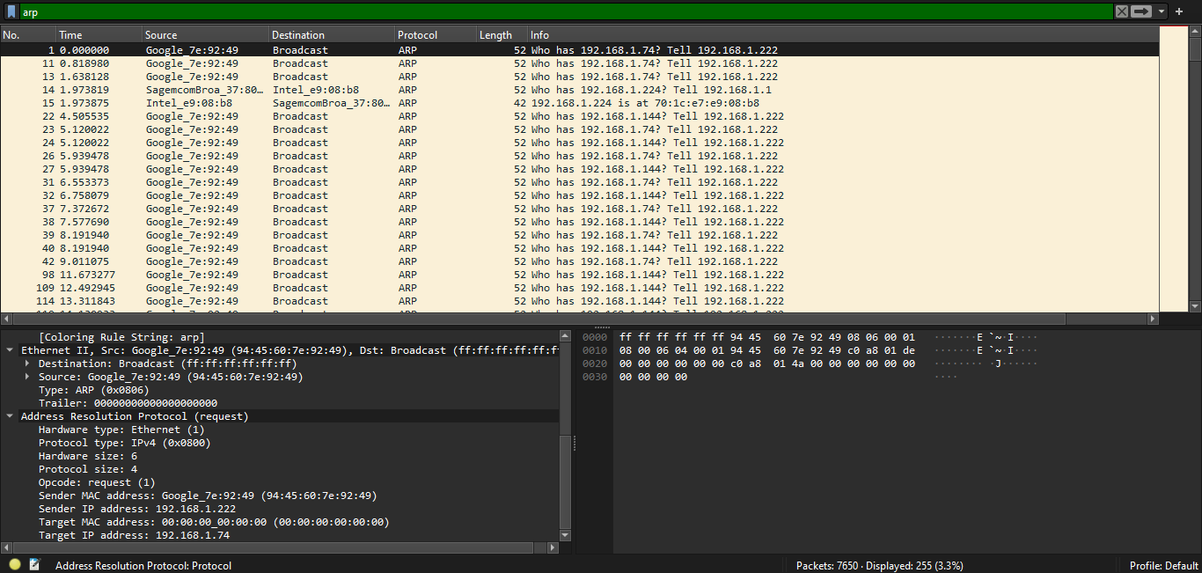
Traffic of devices other than mine
In a capture length of seven minutes, I got a total of 255 ARP messages. Which is the traffic of other devices. ARP is a common protocol that lets us see the traffic of other devices that are on the same network.
Although monitoring network activity on other devices within the same LAN can be difficult, it is possible. Ethernet switches are designed to route Ethernet frames to the correct port based on the MAC address, making it so that only frames intended for or originating from your NIC are visible, including broadcast frames like ARP. However, an arp poisoning tool like Ettercap can be used to capture traffic from other devices.
